Output File.

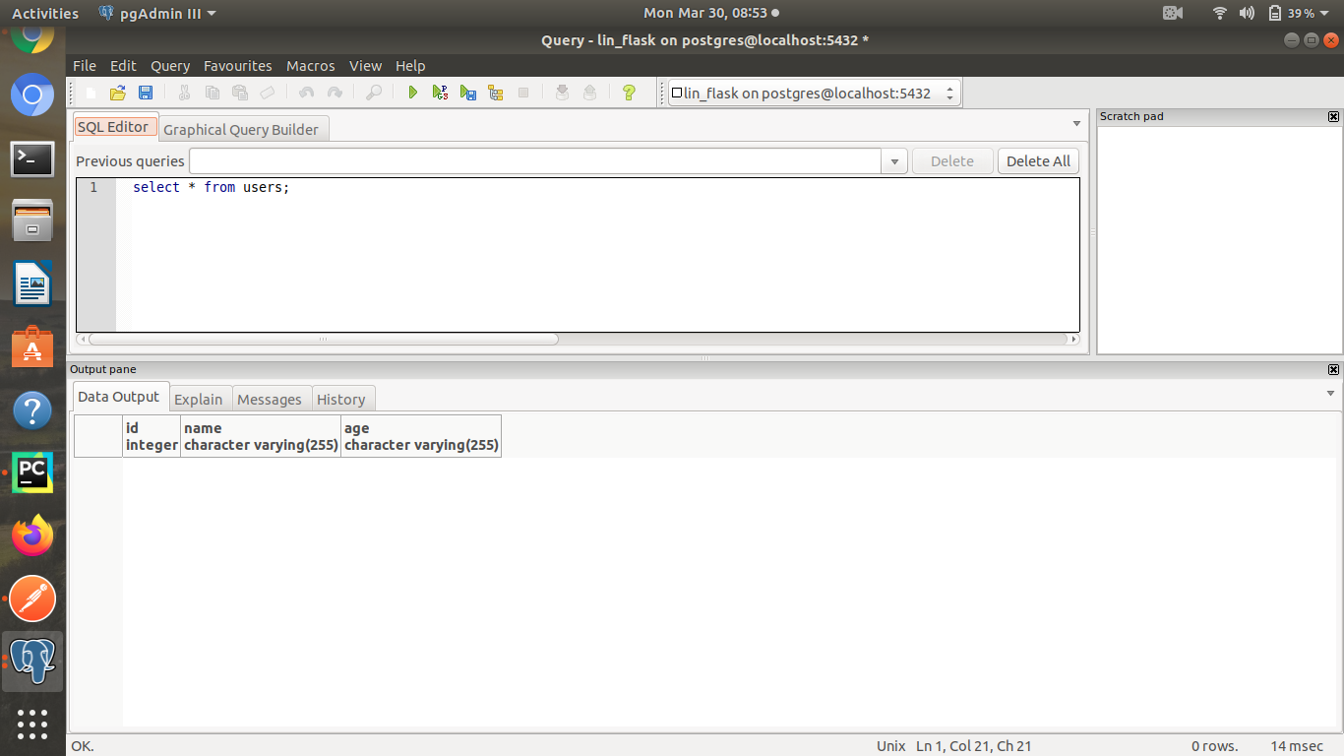
Database Structure : id,name,age (users table)

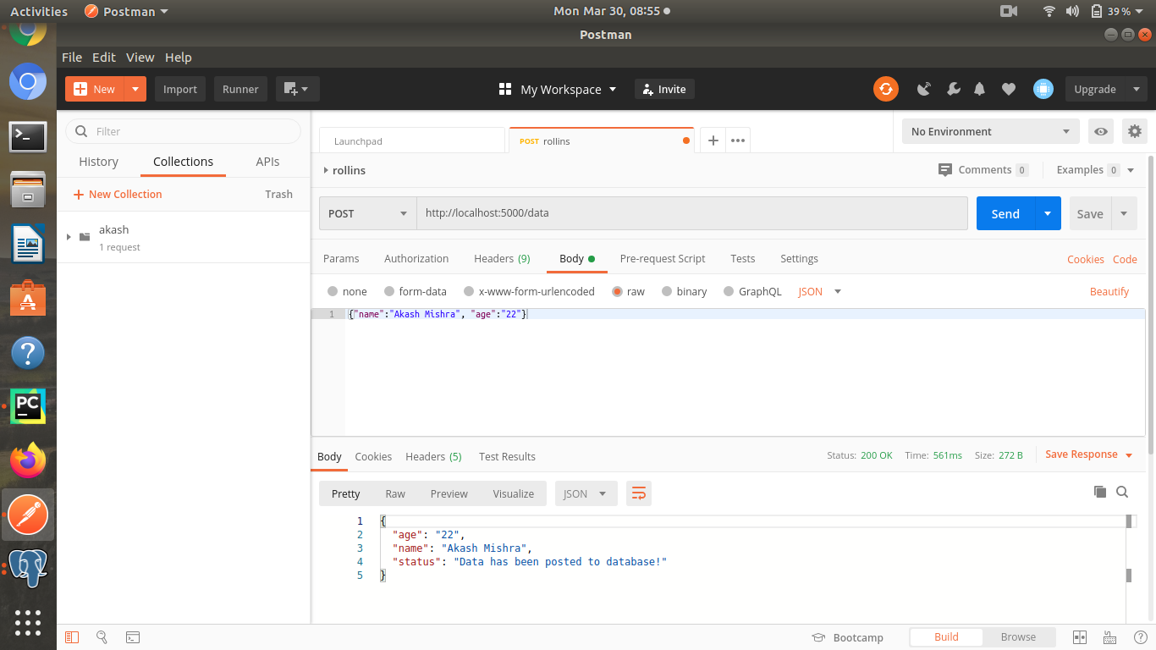
Posting 1st data in Database using Postman.
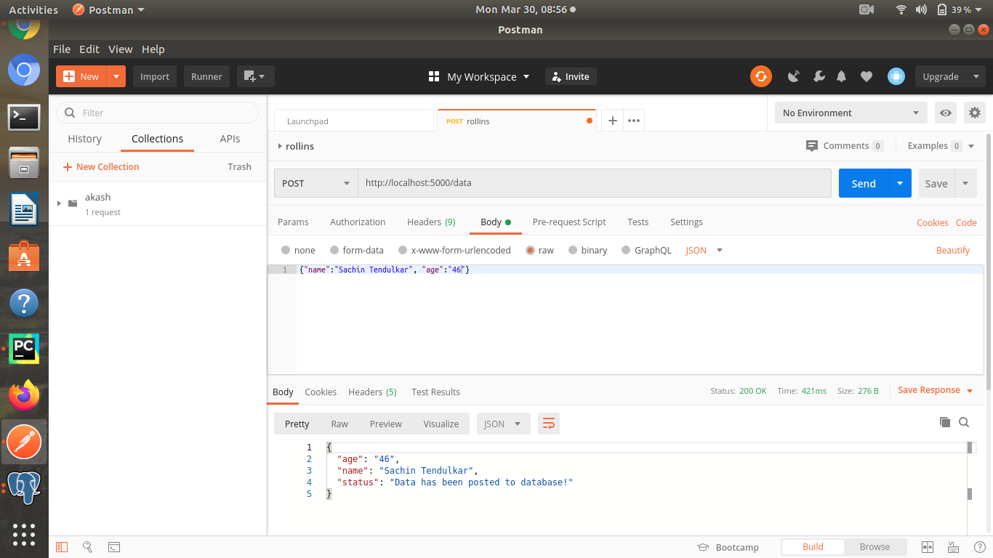
Adding 2nd data to postgres database using Postman.

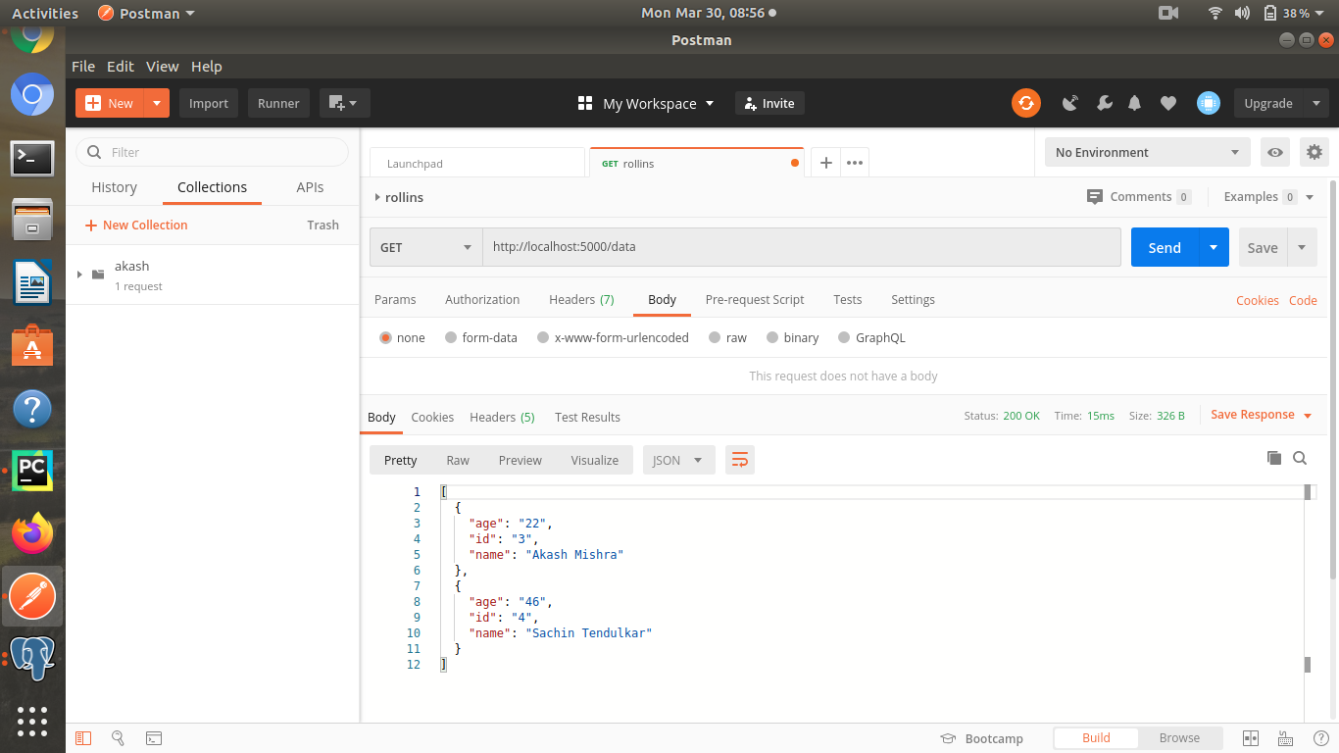
GET operation after POSTing the data.

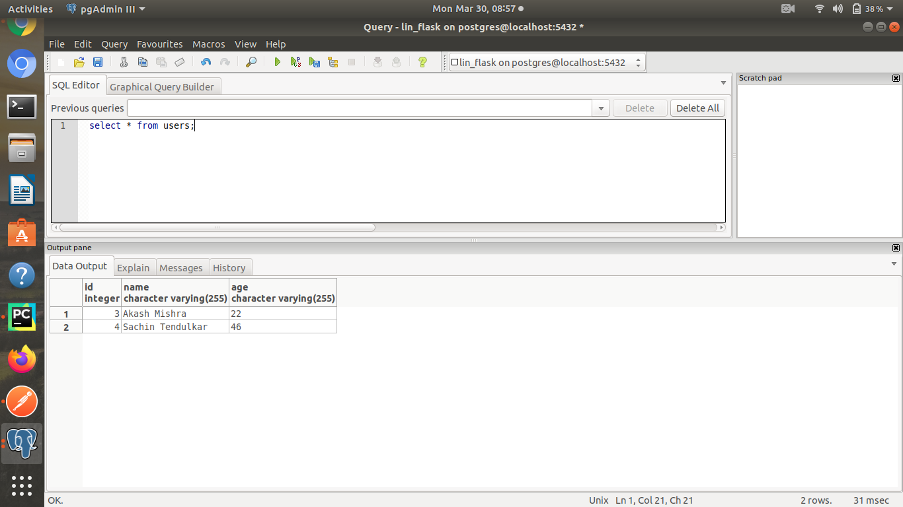
Updated table in Postgres database.

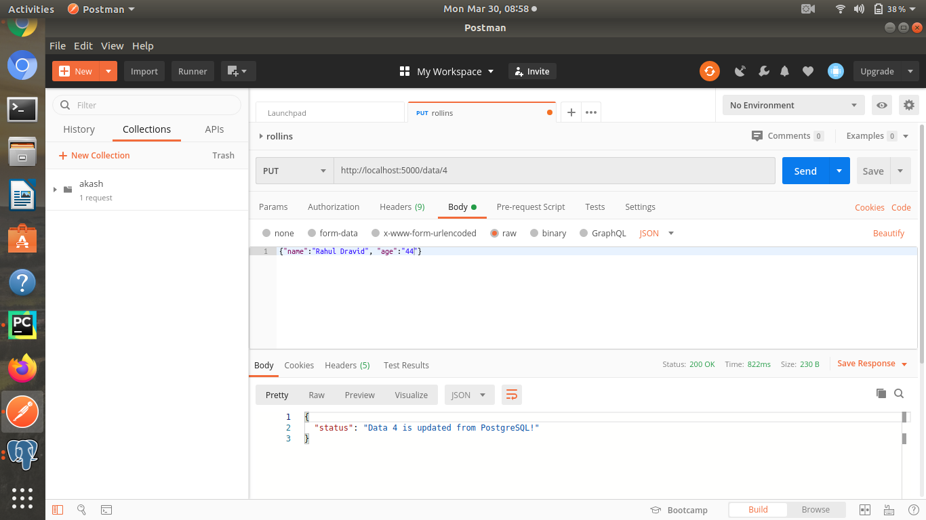
PUT operation to Update the Data in database.
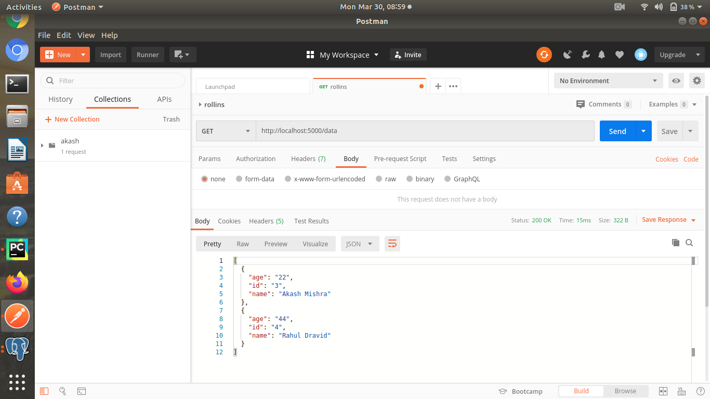
Updated data after PUT operation.

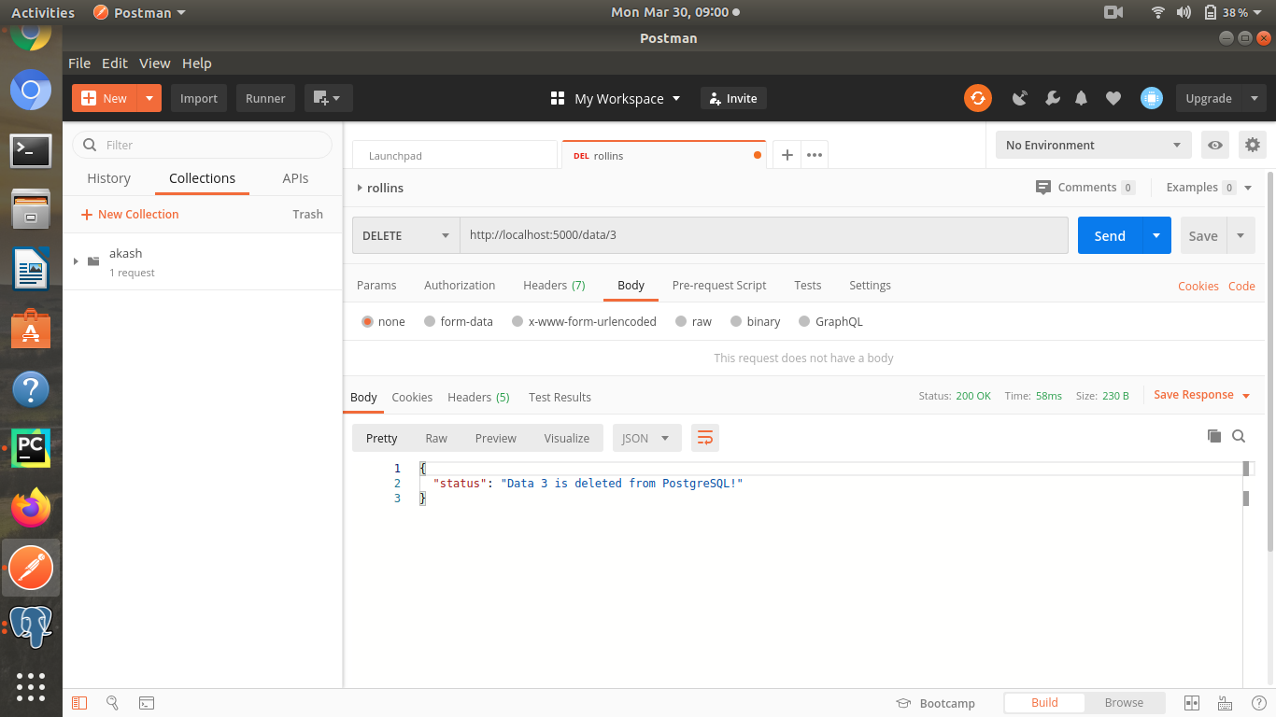
Deleting a data based on id : data/id DELETE operation
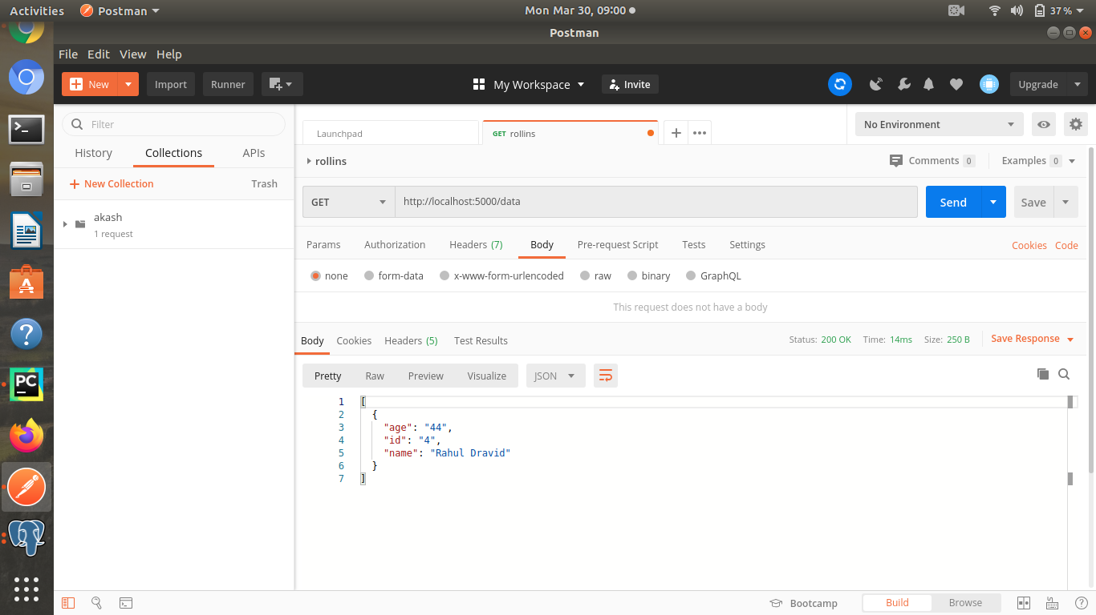
Updated data after deletion operation.

